Joel Atkinson
February7, 2026

CSD430 Server Side Development
Assignment 5&6-2

Index.jsp code:
<%-- Joel Atkinson, February 7, 2026, CSD430 Server Side Development Assignment 5&6
The purpose of this assignment is to create a database called CSD430 in SQL, then create a table (I chose U.S. states),
and populate that table with at least 5 data fields. From there create a JavaBean to pull the data from the database
which will be linked to the .jsp files in order to have a selection of a U.S. state and then to display the data of that
state in a table. In addition to this, also create an index.jsp file for this course as the landing page where all of our
assignments will be held. I went ahead and also created .css style sheets for both the index as well as the module 5/6
.jsp files. --%>
<%@ page contentType="text/html; charset=UTF-8" pageEncoding="UTF-8" %>
<!DOCTYPE html>
<html lang="en">
<head>
<meta charset="UTF-8">
<meta name="viewport" content="width=device-width, initial-scale=1.0">
<title>CSD430 - Server Side Development</title>
<link rel="stylesheet" href="<%=request.getContextPath()%>/index.css">
</head>
<body>
<div class="page">
<div class="header">
<h1>CSD430 - Server Side Development</h1>
<p>This index page contains links to all module assignments for this course.</p>
</div>
<hr class="gold-divider">
<div class="content">
<h2>Assignments</h2>
<div class="assignments">
<ul>
<li>
<a class="assignment-link" href="selectState.jsp">
<span class="assignment-title">
Assignment Part 1 - State Database Lookup
</span>
<span class="assignment-desc">
State Record Display
</span>
</a>
</li>
</ul>
</div>
</div>
<hr class="footer-divider">
<div class="footer">
<p>© Joel Atkinson</p>
<p>Bellevue University</p>
<p>2026</p>
</div>
</div>
</body>
</html>

Index.css code:
/* Joel Atkinson, February 7, 2026, CSD430 Server Side Development Assignment 5&6
The purpose of this assignment is to create a database called CSD430 in SQL, then create a table (I chose U.S. states),
and populate that table with at least 5 data fields. From there create a JavaBean to pull the data from the database
which will be linked to the .jsp files in order to have a selection of a U.S. state and then to display the data of that
state in a table. In addition to this, also create an index.jsp file for this course as the landing page where all of our
assignments will be held. I went ahead and also created .css style sheets for both the index as well as the module 5/6
.jsp files. */
* {
box-sizing: border-box;
}
html, body {
height: 100%;
margin: 0;
padding: 0;
}
body {
font-family: Arial, Helvetica, sans-serif;
background-color: #eaeaea;
color: #000;
line-height: 1.6;
}
.page {
min-height: 100vh;
display: flex;
flex-direction: column;
}
.header {
background-color: #5b2c83;
padding: 40px 20px;
text-align: center;
color: white;
}
.header h1 {
color: #DAA520; /* Gold */
margin: 0 0 12px 0;
font-size: 2.4em;
}
.header p {
color: white;
max-width: 900px;
margin: 0 auto;
font-size: 1.1em;
}
.gold-divider {
border: none;
height: 4px;
background-color: #DAA520;
margin: 0;
}
.footer-divider {
border: none;
height: 5px;
background-color: #5b2c83;
margin: 0;
}
.content {
background-color: white;
padding: 40px 20px;
flex: 1;
width: 100%;
}
.content h2 {
max-width: 900px;
margin: 0 auto 28px auto;
text-align: center;
color: #5b2c83;
}
.assignments {
max-width: 900px;
margin: 0 auto;
}
.assignments ul {
list-style: none;
padding: 0;
margin: 0;
}
.assignments li {
margin-bottom: 20px;
}
/* ===== Assignment Card ===== */
.assignment-link {
display: flex;
justify-content: space-between;
align-items: center;
padding: 18px 22px;
border-radius: 10px;
border: 2px solid #5b2c83;
text-decoration: none;
background-color: #ffffff;
box-shadow: 0 4px 10px rgba(0,0,0,0.1);
transition: all 0.18s ease;
}
.assignment-link:hover {
background-color: #DAA520;
color: #1a1a1a;
transform: translateY(-2px);
box-shadow: 0 8px 16px rgba(0,0,0,0.15);
}
.assignment-title {
font-weight: bold;
color: #5b2c83;
font-size: 1.1em;
}
.assignment-desc {
font-size: 0.95em;
color: #444;
}
.assignment-link:hover .assignment-title,
.assignment-link:hover .assignment-desc {
color: #1a1a1a;
}
.footer {
background-color: #FFFFFF;
padding: 24px 20px;
text-align: center;
font-size: 0.95em;
color: #5b2c83;
font-weight: bold;
width: 100%;
}
.footer p {
margin: 8px 0;
font-weight: 500;
}

StatesBean.java code:
package beans;
import java.sql.*;
import java.util.ArrayList;
import java.util.List;
/* Joel Atkinson, February 7, 2026, CSD430 Server Side Development Assignment 5&6
The purpose of this assignment is to create a database called CSD430 in SQL, then create a table (I chose U.S. states),
and populate that table with at least 5 data fields. From there create a JavaBean to pull the data from the database
which will be linked to the .jsp files in order to have a selection of a U.S. state and then to display the data of that
state in a table. In addition to this, also create an index.jsp file for this course as the landing page where all of our
assignments will be held. I went ahead and also created .css style sheets for both the index as well as the module 5/6
.jsp files. */
public class StatesBean {
// JDBC connection parameters
private static final String JDBC_URL = "jdbc:mysql://localhost:3306/CSD430?useSSL=false&serverTimezone=UTC";
private static final String JDBC_USER = "student1";
private static final String JDBC_PASS = "pass";
private static final String JDBC_DRIVER = "com.mysql.cj.jdbc.Driver";
static {
// Attempt to load the MySQL driver
try {
Class.forName(JDBC_DRIVER);
} catch (ClassNotFoundException e) {
e.printStackTrace();
}
}
private Connection getConnection() throws SQLException {
return DriverManager.getConnection(JDBC_URL, JDBC_USER, JDBC_PASS);
}
public static class StateOption {
public final int id;
public final String name;
public StateOption(int id, String name) {
this.id = id;
this.name = name;
}
}
public static class StateRecord {
public int id;
public String stateCode;
public String stateName;
public String capital;
public String region;
public Long population;
public Integer yearFounded;
}
public List<StateOption> getStateOptions() {
List<StateOption> options = new ArrayList<>();
String sql = "SELECT id, state_name FROM Joel_states_data ORDER BY state_name";
try (Connection conn = getConnection();
PreparedStatement ps = conn.prepareStatement(sql);
ResultSet rs = ps.executeQuery()) {
while (rs.next()) {
int id = rs.getInt("id");
String name = rs.getString("state_name");
options.add(new StateOption(id, name));
}
} catch (SQLException e) {
e.printStackTrace();
}
return options;
}
public List<Integer> getAllIds() {
List<Integer> ids = new ArrayList<>();
String sql = "SELECT id FROM Joel_states_data ORDER BY id";
try (Connection conn = getConnection();
PreparedStatement ps = conn.prepareStatement(sql);
ResultSet rs = ps.executeQuery()) {
while (rs.next()) {
ids.add(rs.getInt("id"));
}
} catch (SQLException e) {
e.printStackTrace();
}
return ids;
}
public StateRecord getStateById(int id) {
String sql = "SELECT id, state_code, state_name, capital, region, population, year_founded " +
"FROM Joel_states_data WHERE id = ?";
try (Connection conn = getConnection();
PreparedStatement ps = conn.prepareStatement(sql)) {
ps.setInt(1, id);
try (ResultSet rs = ps.executeQuery()) {
if (rs.next()) {
StateRecord s = new StateRecord();
s.id = rs.getInt("id");
s.stateCode = rs.getString("state_code");
s.stateName = rs.getString("state_name");
s.capital = rs.getString("capital");
s.region = rs.getString("region");
long popVal = rs.getLong("population");
if (rs.wasNull()) {
s.population = null;
} else {
s.population = popVal;
}
int yf = rs.getInt("year_founded");
if (rs.wasNull()) {
s.yearFounded = null;
} else {
s.yearFounded = yf;
}
return s;
}
}
} catch (SQLException e) {
e.printStackTrace();
}
return null;
}
}

selectState.jsp code:
<%-- Joel Atkinson, February 7, 2026, CSD430 Server Side Development Assignment 5&6
The purpose of this assignment is to create a database called CSD430 in SQL, then create a table (I chose U.S. states),
and populate that table with at least 5 data fields. From there create a JavaBean to pull the data from the database
which will be linked to the .jsp files in order to have a selection of a U.S. state and then to display the data of that
state in a table. In addition to this, also create an index.jsp file for this course as the landing page where all of our
assignments will be held. I went ahead and also created .css style sheets for both the index as well as the module 5/6
.jsp files. --%>
<%@ page contentType="text/html; charset=UTF-8" pageEncoding="UTF-8" %>
<%@ page import="beans.StatesBean" %>
<%@ page import="beans.StatesBean.StateOption" %>
<%@ page import="java.util.List" %>
<!DOCTYPE html>
<html lang="en">
<head>
<meta charset="UTF-8">
<meta name="viewport" content="width=device-width, initial-scale=1.0">
<title>State Lookup (CSD430)</title>
<link rel="stylesheet" href="<%=request.getContextPath()%>/assignment_5_1.css">
</head>
<body>
<div class="page">
<div class="header">
<h1>State Lookup (CSD430)</h1>
<p>Select a state you would like to display data for.</p>
</div>
<hr class="gold-divider">
<div class="content">
<%
StatesBean bean = new StatesBean();
List<StateOption> options = bean.getStateOptions();
%>
<div class="form-card">
<form action="displayState.jsp" method="post">
<label for="id">Choose a State:</label>
<select name="id" id="id">
<% for (StateOption opt : options) { %>
<option value="<%= opt.id %>"><%= opt.name %></option>
<% } %>
</select>
<div class="button-row">
<button type="submit">Show Record</button>
</div>
</form>
</div>
</div>
<hr class="footer-divider">
<div class="footer">
<p>© Joel Atkinson</p>
<p>Bellevue University</p>
<p>2026</p>
</div>
</div>
</body>
</html>

displayState.jsp code:
<%-- Joel Atkinson, February 7, 2026, CSD430 Server Side Development Assignment 5&6
The purpose of this assignment is to create a database called CSD430 in SQL, then create a table (I chose U.S. states),
and populate that table with at least 5 data fields. From there create a JavaBean to pull the data from the database
which will be linked to the .jsp files in order to have a selection of a U.S. state and then to display the data of that
state in a table. In addition to this, also create an index.jsp file for this course as the landing page where all of our
assignments will be held. I went ahead and also created .css style sheets for both the index as well as the module 5/6
.jsp files. --%>
<%@ page contentType="text/html; charset=UTF-8" pageEncoding="UTF-8" %>
<%@ page import="beans.StatesBean" %>
<%@ page import="beans.StatesBean.StateRecord" %>
<!DOCTYPE html>
<html lang="en">
<head>
<meta charset="UTF-8">
<meta name="viewport" content="width=device-width, initial-scale=1.0">
<title>State Record Display</title>
<link rel="stylesheet" href="<%=request.getContextPath()%>/assignment_5_1.css">
</head>
<body>
<div class="page">
<div class="header">
<h1>Selected State Record</h1>
<p>This page displays the full record retrieved from the database.</p>
</div>
<hr class="gold-divider">
<div class="content">
<%
int id = Integer.parseInt(request.getParameter("id"));
StatesBean bean = new StatesBean();
StateRecord s = bean.getStateById(id);
%>
<%
if (s == null) {
%>
<p><strong>No record found for the selected state.</strong></p>
<%
} else {
%>
<p>
Below is the record retrieved from the database table
<strong>Joel_states_data</strong>.
</p>
<table class="state-table">
<thead>
<tr>
<th>ID</th>
<th>State Name</th>
<th>State Code</th>
<th>Capital</th>
<th>Population</th>
<th>Year Founded</th>
</tr>
</thead>
<tbody>
<tr>
<td><%= s.id %></td>
<td><%= s.stateName %></td>
<td><%= s.stateCode %></td>
<td><%= s.capital %></td>
<td><%= (s.population == null ? "" : s.population) %></td>
<td><%= (s.yearFounded == null ? "" : s.yearFounded) %></td>
</tr>
</tbody>
</table>
<%
}
%>
<div class="link-split">
<a class="link-button" href="selectState.jsp">Back to Dropdown</a>
&nbsp;&nbsp;
<a class="link-button" href="index.jsp">Back to Index</a>
</div>
</div>
<hr class="footer-divider">
<div class="footer">
<p>© Joel Atkinson</p>
<p>Bellevue University</p>
<p>2026</p>
</div>
</div>
</body>
</html>

Assignment_5_1.css code:
/* Joel Atkinson, February 7, 2026, CSD430 Server Side Development Assignment 5&6
The purpose of this assignment is to create a database called CSD430 in SQL, then create a table (I chose U.S. states),
and populate that table with at least 5 data fields. From there create a JavaBean to pull the data from the database
which will be linked to the .jsp files in order to have a selection of a U.S. state and then to display the data of that
state in a table. In addition to this, also create an index.jsp file for this course as the landing page where all of our
assignments will be held. I went ahead and also created .css style sheets for both the index as well as the module 5/6
.jsp files. */
* {
box-sizing: border-box;
}
html, body {
height: 100%;
margin: 0;
padding: 0;
}
body {
font-family: Arial, sans-serif;
background-color: #eaeaea;
color: #000;
line-height: 1.6;
}
.page {
min-height: 100vh;
display: flex;
flex-direction: column;
}
/* Header */
.header {
background-color: #5b2c83;
padding: 40px 20px;
text-align: center;
}
.header h1 {
color: #DAA520;
margin: 0 0 12px 0;
font-size: 2.4em;
}
.header p {
color: white;
max-width: 900px;
margin: 0 auto;
font-size: 1.1em;
}
.gold-divider {
border: none;
height: 4px;
background-color: #DAA520;
margin: 0;
}
.content {
flex: 1 0 auto;
background-color: white;
padding: 40px 20px;
}
.form-card {
max-width: 650px;
margin: 0 auto;
padding: 24px 22px;
border-radius: 10px;
border: 2px solid #5b2c83;
box-shadow: 0 4px 8px rgba(0,0,0,0.08);
background-color: white;
}
label {
font-weight: bold;
color: #5b2c83;
display: block;
margin-bottom: 6px;
}
select {
width: 100%;
padding: 10px 12px;
border-radius: 8px;
border: 2px solid #5b2c83;
font-size: 1em;
margin-bottom: 18px;
}
.button-row {
text-align: center;
}
button {
background-color: #5b2c83;
color: #DAA520;
border: none;
border-radius: 8px;
padding: 11px 24px;
font-size: 1em;
font-weight: bold;
cursor: pointer;
}
button:hover {
background-color: #DAA520;
color: #5b2c83;
box-shadow: #5b2c83 0 0 6px 2px;
}
.footer-divider {
border: none;
height: 4px;
background-color: #5b2c83;
margin: 0;
}
.footer {
background-color: white;
color: #5b2c83;
text-align: center;
padding: 16px 20px;
font-size: 0.95em;
font-weight: 600;
flex-shrink: 0;
}
.footer p {
margin: 4px 0;
}
.footer-divider {
border: none;
height: 4px;
background-color: #5b2c83;
margin: 0;
}
.assignment-footer {
background-color: white;
color: #5b2c83;
text-align: center;
padding: 16px 20px;
font-size: 0.95em;
font-weight: 600;
flex-shrink: 0;
}
.assignment-footer p {
margin: 4px 0;
text-align: center;
}
.state-table {
width: 100%;
border-collapse: collapse;
margin-top: 16px;
table-layout: fixed;
}
.state-table th,
.state-table td {
border: 2px solid #5b2c83;
padding: 10px 12px;
text-align: left;
font-size: 0.95em;
}
.state-table th {
background-color: #5b2c83;
color: #DAA520;
font-weight: bold;
}
.state-table td {
background-color: #ffffff;
color: #000;
}
.state-table td,
.state-table th {
white-space: nowrap;
}
.form-card {
overflow-x: auto;
}
.link-button {
display: inline-block;
background-color: transparent;
color: #5b2c83;
text-decoration: none;
border-radius: 8px;
padding: 10px 20px;
font-size: 1em;
font-weight: bold;
}
.link-button:hover {
box-shadow: #5b2c83 0 0 6px 2px;
}
.link-split {
display: flex;
justify-content: space-between;
align-items: center;
width: 85%;
margin: 24px auto 0 auto;
}

Screenshot of index page output:
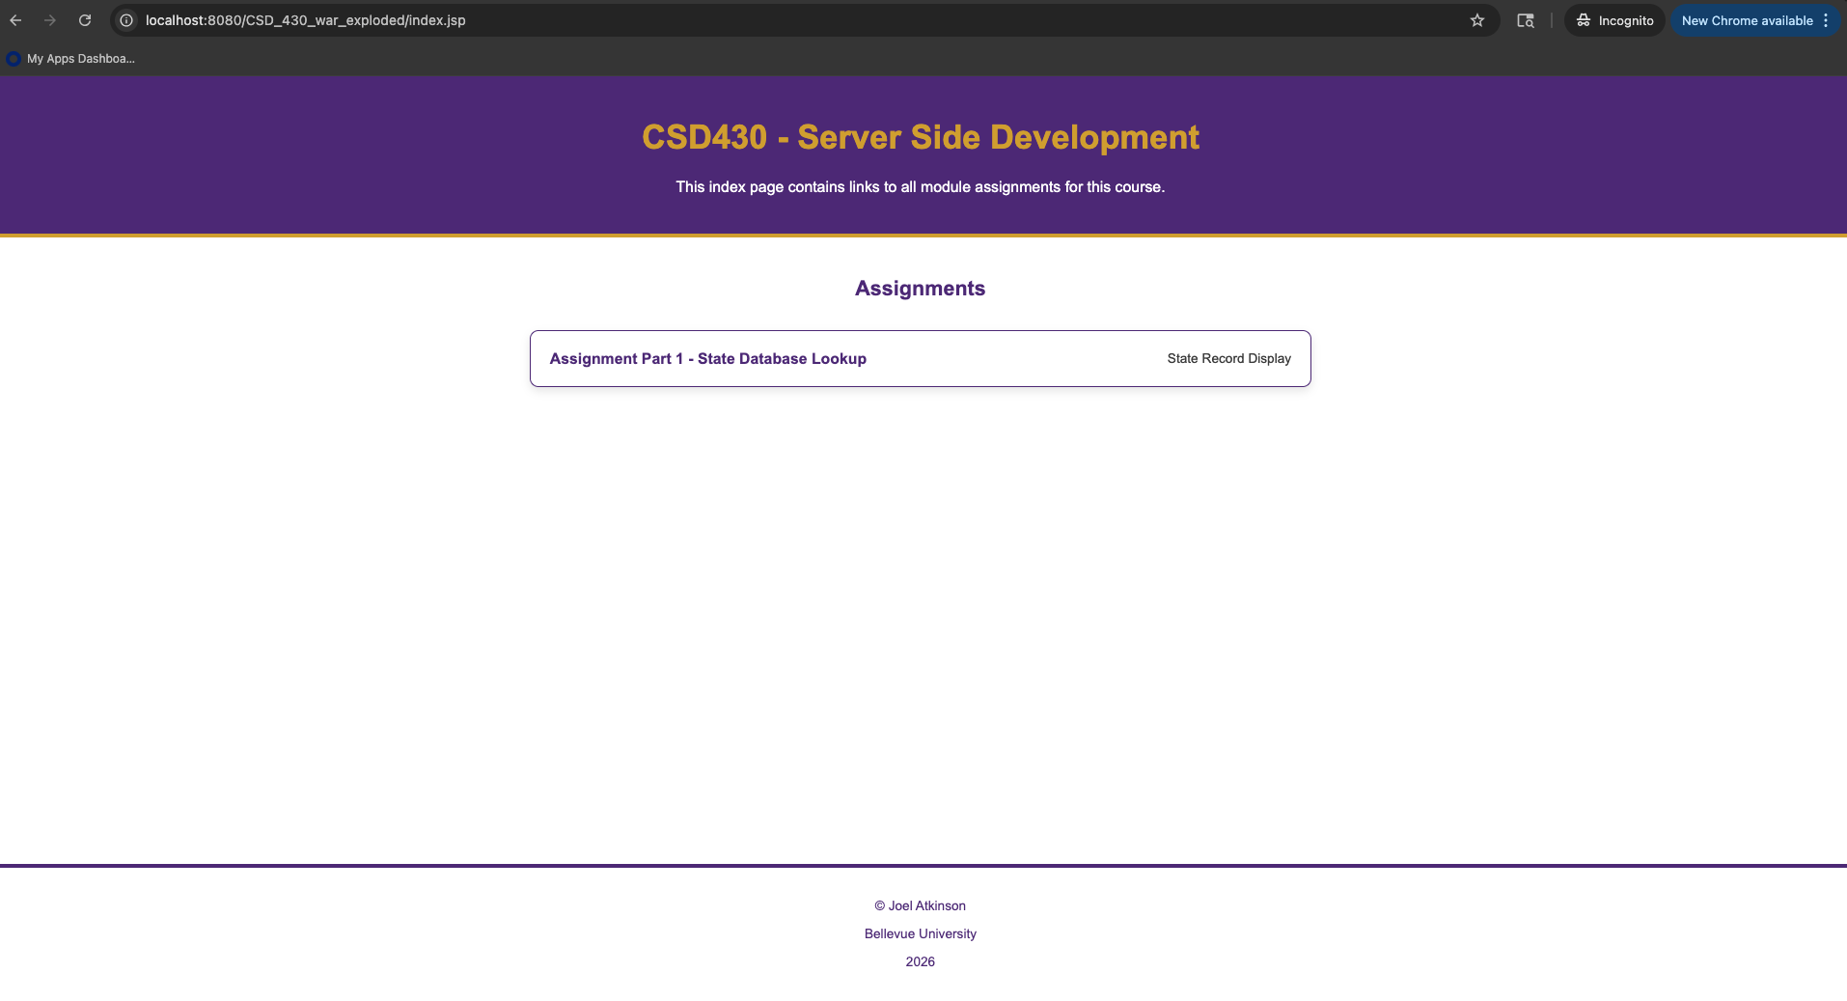

Screenshots of Select State page outputs:
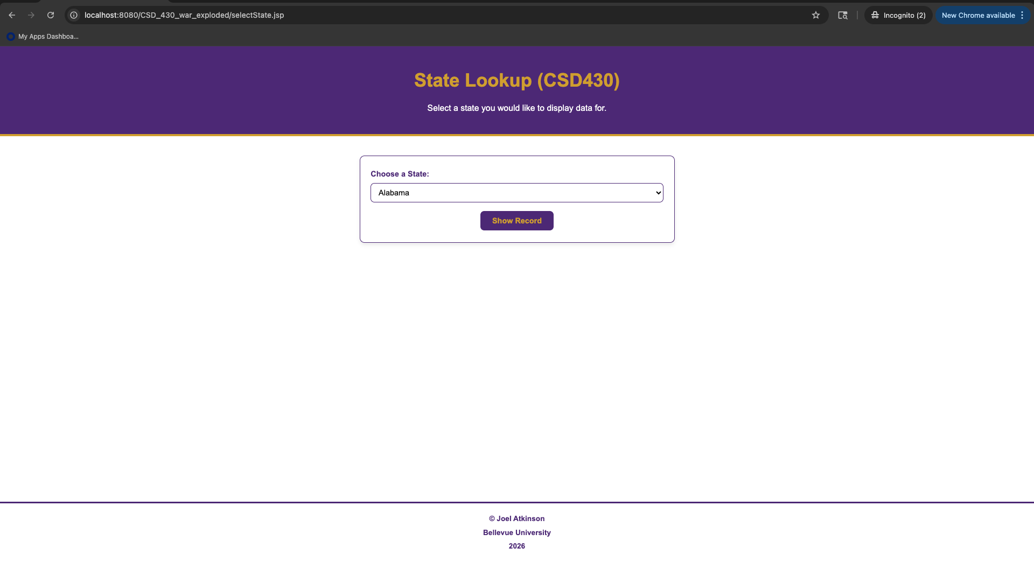
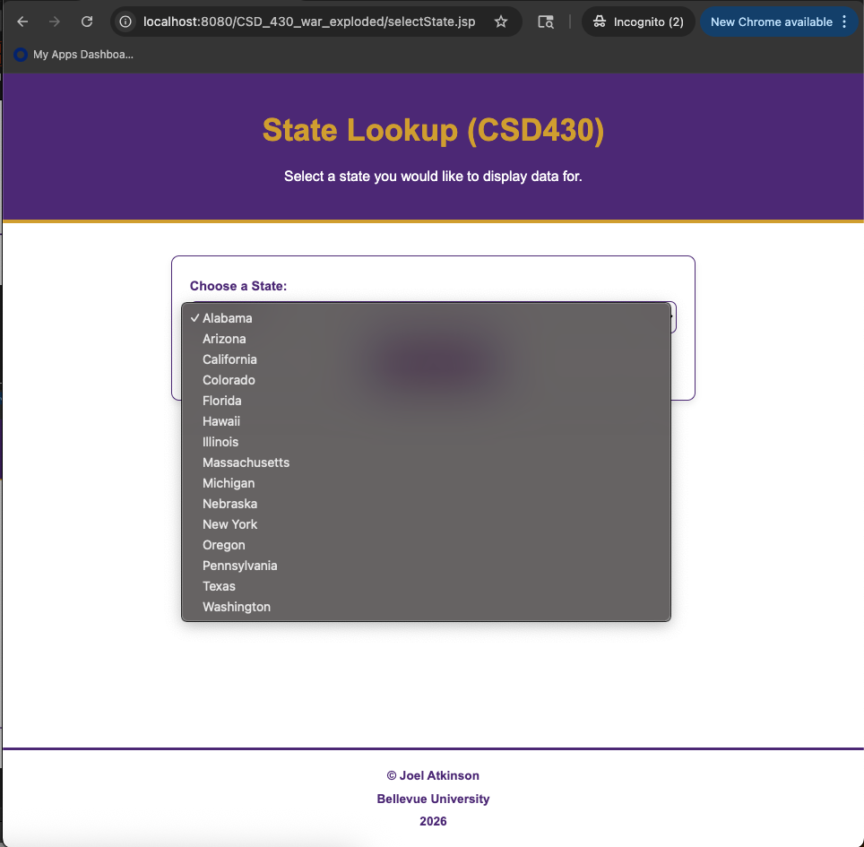

Screenshot of display state output:
